**Media ownership report**

**Rupert Murdoch**

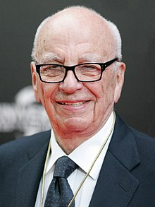

Biography: Born: Keith Rupert Murdoch on 11th March 1931 in Melbourne, Victoria, Australia.

Parents: Keith Murdoch and Elisabeth Joy.

Spouses: Patricia Booker (married 1956 divorced 1967)

Anna Torv married 1967 divorced 1999

Wendi Deng married 1999 divorced 2013

Jerry Hall married 2016

Children: 6 Children, of those Prudence, Elisabeth, Lachlan and James Murdoch have all been involved in the media.

Awards: Received the Companion of the ‘Order of Australia’ in 1984, an award which is an order of chivalry (medieval knightly system with its religious, social, and moral codes) established by Queen Elizabeth the second in 1975 to recognise Australian citizens and other persons for achievement or meritorious service. The award is divided into 5 levels of membership, the ‘Companion of the Order of Australia’ being the second highest level of the award, behind ‘Knight and Dame of the Order of Australia’. This is therefore a highly significant and notorious award Murdoch has achieved.

Rupert Murdoch known for; -Chairman and CEO of News Corporations (1979-2013) -Executive chairman of News Corp 2013-present -Chairman and CEO of 21st Century Fox (2013-15) -Executive Co-chairman of 21st Century Fox (2015-present).

* Australian citizenship; (1931-85), American citizen; (1985-present)
* Political Party: Republican
* Net worth: a whopping US $15.9 billion (June 2018).
* Famous quote: “The world is changing very fast. Big will not beat small anymore. It will be the fast beating the slow”.

**Biography and background:**

**Rupert Murdoch**, (born 11 March 1931) is an Australian-born American [media mogul](https://en.wikipedia.org/wiki/Media_mogul" \o "Media mogul).

Murdoch's father, Sir [Keith Murdoch](https://en.wikipedia.org/wiki/Keith_Murdoch" \o "Keith Murdoch), was a reporter and editor who became a senior executive of [The Herald and Weekly Times](https://en.wikipedia.org/wiki/The_Herald_and_Weekly_Times" \o "The Herald and Weekly Times)publishing company, covering all [Australian](https://en.wikipedia.org/wiki/Australia" \o "Australia) states except [New South Wales](https://en.wikipedia.org/wiki/New_South_Wales" \o "New South Wales). After his father's death in 1952, Murdoch declined to join his late father's registered public company and created his own private company, [News Limited](https://en.wikipedia.org/wiki/News_Limited" \o "News Limited).

In the 1950s and 1960s, Murdoch acquired a number of newspapers in Australia and [New Zealand](https://en.wikipedia.org/wiki/Media_of_New_Zealand" \o "Media of New Zealand) before expanding into the [United Kingdom](https://en.wikipedia.org/wiki/Media_of_the_United_Kingdom" \o "Media of the United Kingdom) in 1969, taking over the [News of the World](https://en.wikipedia.org/wiki/News_of_the_World" \o "News of the World), followed closely by [The Sun](https://en.wikipedia.org/wiki/The_Sun_(United_Kingdom)" \o "The Sun (United Kingdom)). In 1974, Murdoch moved to [New York City](https://en.wikipedia.org/wiki/New_York_City" \o "New York City), to expand into the U.S. market; however, he retained interests in Australia and [Britain](https://en.wikipedia.org/wiki/United_Kingdom" \o "United Kingdom). In 1981, Murdoch bought [The Times](https://en.wikipedia.org/wiki/The_Times" \o "The Times), his first British [broadsheet](https://en.wikipedia.org/wiki/Broadsheet" \o "Broadsheet) and, in 1985, became a [naturalized](https://en.wikipedia.org/wiki/Naturalization" \o "Naturalization) U.S. citizen, giving up his Australian citizenship, to satisfy the legal requirement for U.S. television ownership.

In 1986, keen to adopt newer electronic publishing technologies, Murdoch consolidated his UK printing operations in [Wapping](https://en.wikipedia.org/wiki/Wapping" \o "Wapping), causing bitter industrial disputes. His holding company [News Corporation](https://en.wikipedia.org/wiki/News_Corporation" \o "News Corporation) acquired [Twentieth Century Fox](https://en.wikipedia.org/wiki/20th_Century_Fox" \o "20th Century Fox) (1985), [HarperCollins](https://en.wikipedia.org/wiki/HarperCollins" \o "HarperCollins) (1989), and[The Wall Street Journal](https://en.wikipedia.org/wiki/The_Wall_Street_Journal" \o "The Wall Street Journal) (2007). Murdoch formed the British broadcaster [BSkyB](https://en.wikipedia.org/wiki/Sky_plc" \o "Sky plc) in 1990 and, during the 1990s, expanded into Asian networks and South American television. By 2000, Murdoch's News Corporation owned over 800 companies in more than 50 countries, with a net worth of over $5 billion.

In July 2011, Murdoch faced allegations that his companies, including the [News of the World](https://en.wikipedia.org/wiki/News_of_the_World" \o "News of the World), owned by News Corporation, had been regularly [hacking the phones](https://en.wikipedia.org/wiki/News_International_phone_hacking_scandal" \o "News International phone hacking scandal) of celebrities, royalty, and public citizens. Murdoch faced police and government investigations into bribery and corruption by the British government and [FBI](https://en.wikipedia.org/wiki/Federal_Bureau_of_Investigation" \o "Federal Bureau of Investigation) investigations in the U.S. On 21 July 2012, Murdoch resigned as a director of [News International](https://en.wikipedia.org/wiki/News_International" \o "News International). On 1 July 2015, Murdoch left his post as CEO of [21st Century Fox](https://en.wikipedia.org/wiki/21st_Century_Fox" \o "21st Century Fox). However, Murdoch and his family continue to own both 21st Century Fox and [News Corp](https://en.wikipedia.org/wiki/News_Corp" \o "News Corp) through the Murdoch Family Trust.

In July 2016, after the resignation of [Roger Ailes](https://en.wikipedia.org/wiki/Roger_Ailes" \o "Roger Ailes) due to accusations of sexual harassment, Murdoch was named the acting CEO of [Fox News](https://en.wikipedia.org/wiki/Fox_News" \o "Fox News).

**Early Life:** Keith Rupert Murdoch was born on 11 March 1931 in [Melbourne](https://en.wikipedia.org/wiki/Melbourne" \o "Melbourne), Australia, the son of [Sir Keith Murdoch](https://en.wikipedia.org/wiki/Keith_Murdoch" \o "Keith Murdoch) (1885–1952) and [Dame Elisabeth Murdoch](https://en.wikipedia.org/wiki/Elisabeth_Murdoch_(philanthropist)" \o "Elisabeth Murdoch (philanthropist)) (Nee Greene; 1909–2012). He is of [English](https://en.wikipedia.org/wiki/English_people" \o "English people), [Irish](https://en.wikipedia.org/wiki/Irish_people" \o "Irish people), and [Scottish](https://en.wikipedia.org/wiki/Scottish_people" \o "Scottish people) ancestry. Murdoch's parents were also born in Melbourne. Keith Murdoch was a war correspondent and later a regional newspaper magnate owning two newspapers in [Adelaide](https://en.wikipedia.org/wiki/Adelaide" \o "Adelaide), South Australia, and a radio station in a faraway mining town. Later in life, Keith Rupert chose to use Rupert, the first name of his maternal grandfather.

Murdoch attended [Geelong Grammar School](https://en.wikipedia.org/wiki/Geelong_Grammar_School" \o "Geelong Grammar School), where he was co-editor of the school's official journal The Corian and editor of the student journal If Revived. He took his school's cricket team to the National Junior Finals. He worked part-time at the *Melbourne Herald* and was groomed by his father to take over the family business. Murdoch studied [Philosophy, Politics and Economics](https://en.wikipedia.org/wiki/Philosophy,_Politics_and_Economics" \o "Philosophy, Politics and Economics) at [Worcester College](https://en.wikipedia.org/wiki/Worcester_College,_Oxford" \o "Worcester College, Oxford), [Oxford](https://en.wikipedia.org/wiki/University_of_Oxford" \o "University of Oxford) in England, where he supported the [Labour Party](https://en.wikipedia.org/wiki/Labour_Party_(UK)" \o "Labour Party (UK)), stood for Secretary of the Labour Club and managed [Oxford Student Publications Limited](https://en.wikipedia.org/wiki/Oxford_Student_Publications_Limited" \o "Oxford Student Publications Limited), the publishing house of *[Cherwell](https://en.wikipedia.org/wiki/Cherwell_(newspaper)" \o "Cherwell (newspaper))*. After her husband's death from cancer in 1952, Elisabeth Murdoch (mother) did charity work, as life governor of the [Royal Women's Hospital](https://en.wikipedia.org/wiki/Royal_Women's_Hospital" \o "Royal Women's Hospital) in Melbourne and established the [Murdoch Childrens Research Institute](https://en.wikipedia.org/wiki/Murdoch_Childrens_Research_Institute" \o "Murdoch Childrens Research Institute). At the age of 102 (in 2011), she had 74 descendants. Murdoch completed an MA (Master of Arts Degree) before working as a sub-editor with the [Daily Express](https://en.wikipedia.org/wiki/Daily_Express" \o "Daily Express) for two years.

**Media companies and market share:**

Murdoch and his family’s major company:

**News Corporation:**

Although Murdoch left his position as CEO of 21st Century Fox in 2015, Murdoch and his family still own 21st Century Fox and News Corporation through the Murdoch Family Trust. Murdoch and News Corporation have always owned a large share of the media industry over the years. News Corporation is a major media company which owns some of the biggest and well-known channels. News Corps has many subsidiaries, they are; -Fox News -Fox Entertainment Group -Dow Jones and Company -Market Watch -21st Century Fox -News UK -VCCircle -Harper Collins -Sky Italia -REA Group -Move -Storyful -Star India -Fox Sports Networks -20th Century Fox Television -20th Century Fox Home Entertainment -News America Marketing -Harper Collins UK -DAS Productions -News Corp Australia -Ruby Newco LLC -Nationwide News -Fox Television Stations of Philadelphia -Fox Sports Digital Media -The Herald and Weekly Times -Fox 21 Television Studios -MyNetworkTV -Blue Sky Studios -S&P Dow Jones Indices -Cisco Videoscape -Zondervan -Intermix Media -FX Movie Channel -Zee Entertainment Enterprises -Sky Racing -Fox -Fox Music -Scout.com -Local Media Group -Factiva -News Holdings -News Group Newspapers -News Digital Media

**How it all happened-how News Corp Australia was formed:**

News Corp Australia (formerly News Limited) is one of Australia's largest media companies, employing more than 8,000 staff nationwide and approximately 3,000 journalists. The publicly listed company's interests span newspaper and magazine publishing, Internet, subscription television, market research, DVD and film distribution, and film and television production trading assets.

News Corp Australia owns approximately 142 daily, Sunday, weekly, bi-weekly and tri-weekly newspapers, of which three are free commuter titles and 102 are suburban publications (including 16 in which News Corp Australia has a 50% interest). News Corp Australia publishes a nationally distributed newspaper in Australia, a metropolitan newspaper in each of the Australian cities of Sydney, Melbourne, Brisbane, Adelaide, Perth (Sundays only), Hobart and Darwin and groups of suburban newspapers in the suburbs of Sydney, Melbourne, Adelaide, Brisbane and Perth. The company publishes a further thirty magazine titles across Australia. According to the Finkelstein Review of Media and Media Regulation, in 2011 News Corp Australia (then News Limited) accounted for 23% of the newspaper titles in Australia.

With interests in digital media, the company's sites include news.com.au, Business Spectator and Eureka Report, Kidspot.com.au, taste.com.au and homelife.com.au. It has 50% stakes in CareerOne.com.au and carsguide.com.au, a share in REA Group that operates www.realestate.com.au, as well as websites for most newspaper and magazine titles. The company's other Australian assets include all of Fox Sports Australia, 65% ownership of subscription television provider Foxtel, 65% ownership of the combined entity of Fox Sports (Australia) / Foxtel merger and shares in the Brisbane Broncos NRL team.

Until the formation of News Corporation in 1979, News Limited was the principal holding company for the business interests of Rupert Murdoch and his family. Since then, News Limited had been wholly owned by News Corporation. In 2004, News Corporation announced its intention to reincorporate to the United States. On 3 November News Corp Limited ceased trading on the Australian Stock Exchange; and on 8 November, News Corporation began trading on the New York Stock Exchange. On 28 June 2013, News Corporation was split into two separate companies. Murdoch's newspaper interests became News Corp, which was the new parent company of News Limited. News Limited was renamed News Corp Australia following the listing of the new News Corp on 1 July 2013.

Rupert Murdoch controls 70% of the capital city newspaper circulation in Australia.

**News Corp America 1979-2013:**

The original News Corporation or News Corp. was an American multinational mass media corporation headquartered in New York City. It was the world's fourth-largest media group in 2014 in terms of revenue. Board members include prominent former Spanish prime minister Jose Maria Aznar.

News Corporation was a publicly traded company listed on the NASDAQ. Formerly incorporated in Adelaide, South Australia, the company was re-incorporated under Delaware General Corporation Law after a majority of shareholders approved the move on 12 November 2004. News Corporation was headquartered at 1211 Avenue of the Americas, New York, in the newer 1960s–1970s corridor of the Rockefeller Center complex.

On 28 June 2012, after concerns from shareholders in response to its recent scandals and to "unlock even greater long-term shareholder value", founder Rupert Murdoch announced that News Corporation's assets would be split into two publicly traded companies, one oriented towards media, and the other towards publishing. The corporate spin-off formally took place on 28 June 2013; where the present News Corp. was renamed 21st Century Fox and consists primarily of media outlets, while a new News Corp was formed to take on the publishing and Australian broadcasting assets.

Its major holdings at the time of the split were News Limited (a group of newspaper publishers in Murdoch's native Australia), News International (a newspaper publisher in the United Kingdom, whose properties include The Times, The Sun, and the now-defunct News of the World—which was the subject of a phone hacking scandal that led to its closure in July 2011), Dow Jones & Company (an American publisher of financial news outlets, including The Wall Street Journal), the book publisher HarperCollins, and the Fox Entertainment Group (owners of the 20th Century Fox film studio and the Fox Broadcasting Company—one of the United States' major television networks).

The original News Corp earned a revenue of US $33.706 billion (as of 2012).

**News Corporation America today (2013-present):**

News Corporation (officially referred to and trading as News Corp) is an American multinational mass media company, formed as a spin-off of the former News Corporation (as founded by Rupert Murdoch in 1979) focusing on newspapers and publishing.

It is one of two companies which succeeded the former News Corporation, alongside 21st Century Fox—which consists of the old News Corporation's broadcasting and media properties, such as Fox Entertainment Group. The spin-out was structured so that 21st Century Fox would be the legal successor and continuation of the old News Corporation, with the new News Corp being an entirely new company formed by a stock split.

Its notable assets include Dow Jones & Company (publisher of The Wall Street Journal), News UK and News Corp Australia, as well as book publisher HarperCollins.

The new News Corp has made a revenue so far of US $8.633 billion (2015). This new corporation is primarily focused on publishing newspapers. Lachlan Murdoch, Rupert’s son, shares the role of executive co-chairman of the company with Rupert himself.

News Corp America (head of News Corp) owns News Corp Australia.

News Corp owns a long list of media outlets, owning a media outlet in each of Australia’s states. Here is some of the many different assets News Corp America owns;

**Television:**

Foxtel (50%),Fox Sports Pty Limited,Fox Sports,Fox Sports News,Fox Footy,Australian News Channel,Sky News Live,Sky News Business,Sky News Weather,Sky News New Zealand,Australia Channel.

**Internet:**

BallBall—Online soccer broadcasts to Japan, Indonesia and Vietnam.

Punters.com.au — Australian horse racing and bookmaker affiliate.

**Magazines and inserts:**

Australian Golf Digest,Australian Good Taste (with Woolworths Supermarkets),Australian Parents (with Woolworths Supermarkets),Lifestyle Pools + outdoor design,MasterChef Magazine,SmartSource Magazine,Super Food Ideas,Vogue Australia.

**Metropolitan newspapers, magazines and news distribution channels owned by News Corp:**

* News Corp Australia titles account for 59% of the sales of all daily newspapers, with sales of 17.3 million papers a week, making it Australia’s most influential newspaper publisher by a considerable margin. Among capital city and national daily newspapers, which are by far the most influential in setting the news agenda, News Corporation titles accounted for 65% of circulation in 2011. Fairfax Media, the next biggest publisher, controlled just 25%.

News Corp therefore had/has a big influence in setting the agenda for Australian newspaper readers.

News Corp owns newspapers such as;

New South Wales: The Daily Telegraph, and The Sunday Telegraph,Victoria: Herald Sun, Sunday Herald Sun,Queensland: The Courier Mail, The Sunday Mail,South Australia: The Advertiser, The Sunday Mail,Western Australia: The Western Times, Tasmania: The Mercury, The Sunday Tasmanian, Northern Territory: Northern Territory News, The Sunday Territorian ,National: The Australian including weekly insert magazine The Deal and monthly insert magazine (wish),The Weekend Australian including insert magazine The Weekend Australian Magazine,Australian Associated Press (45%),www.news.com.au National online news website

**Newspapers and information services owned by News**:

Corp United Kingdom: News Corp UK and Ireland owned by American News Corp. The Sun, The Times, The Sunday Times, all owned by News Corp, and News Corp partly owns Press Association (one of 26 stakeholders).

**Community suburban newspapers:**

**Sydney:**Cumberland/Courier (NSW) newspapers[19],Blacktown Advocate**Melbourne:**Leader (Vic) newspapers,Bayside Leader **Brisbane:** City News,City North News,City South News,North-West News**Adelaide:**Messenger (SA) newspapers,Adelaide Matters,East Torrens Messenger**Perth:**Community (WA) newspapers (50.1%),Advocate,Canning Times,Comment News,Eastern Reporter,Fremantle-Cockburn Gazette,Guardian Express,Gazette,Joondalup-Wanneroo Times,North Coast Times,Stirling Times,Weekender,Western Suburbs Weekly.**Darwin:**Sun (NT) newspapers,Darwin Sun**New South Wales:**Tweed Sun', and Tweed Daily News.**Victoria:**Echo,Geelong Advertiser,GeelongNEWS,The Weekly Times.**Queensland:**Bowen Independent,Cairns Sun,Gold Coast Bulletin,Gold Coast Sun,The Cairns Post**Tasmania:**Derwent Valley Gazette, and Tasmanian Country.**Northern Territory:**Centralian Advocate**Papua New Guinea:**Papua New Guinea Post-Courier (63%)**United States:**New York Post,Wall Street Journal,realtor.com **International:**Dow Jones & Company,Consumer Media Group,The Wall Street Journal – the leading US financial newspaper,Wall Street Journal Europe,Wall Street Journal Asia,Barron's – weekly financial markets magazine,Marketwatch – financial news and information website,Financial News,Heat Street - news and opinion website,Mansion Global - global luxury property website, Enterprise Media Group,Dow Jones Newswires – global, real-time news and information provider,Factiva – provides business news and information together with content delivery tools and services,Dow Jones Indexes – stock market indexes and indicators, including the Dow Jones Industrial Average. (10% ownership),Dow Jones Financial Information Services – produces databases, electronic media, newsletters, conferences, directories, and other information services on specialised markets and industry sectors,Betten Financial News – leading Dutch language financial and economic news service.

Strategic Alliances: STOXX (33%) – joint venture with Deutsche Boerse and SWG Group for the development and distribution of Dow Jones STOXX indices,Wireless Group,Talksport.

**Books:** HarperCollins, 4th Estate,Collins,Ecco Press,Harlequin Enterprises,Harper Perennial.

As can be seen by this list, News Corp own an absolutely massive list of subsidiaries. This is also not every single book, newspaper, and information service News Corp owns, there’s several more of each. The list is endless.

Media Interests Australia snapshot (includes all the big media owners) December 2016:

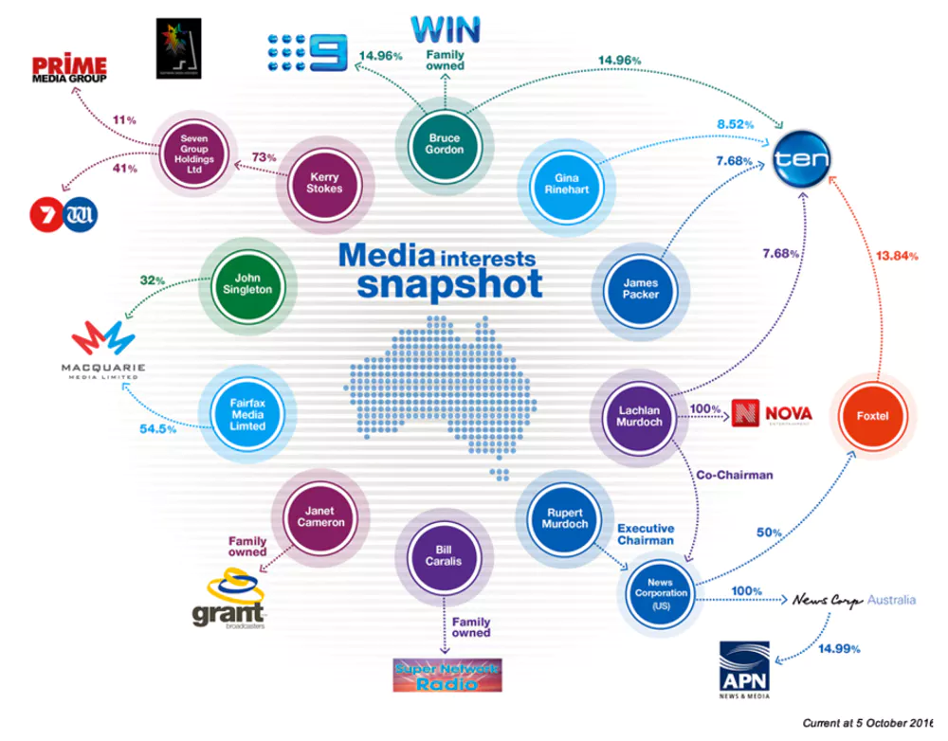

**Political agenda and communication theory:**

In 2007, American journalist Ken Auletta spent a great deal of time with Rupert Murdoch while writing a magazine profile of him. Auletta observed that Murdoch was frequently on the phone to his editors and this prompted him to ask: “of all the things in your business empire, what gives you the most pleasure?” Murdoch instantly replied: “being involved with the editor of a paper in a day-to-day campaign…trying to influence people”.

There is a huge degree of influence exerted by Rupert Murdoch and his newspapers on Australian political life.

For example, Murdoch has had an influence on many elections previously, especially in the UK. In the 1992 UK election, The Sun, his biggest selling tabloid in the UK and editorially a kissing cousin of Sydney’s Daily Telegraph, claimed victory on behalf of the Conservative party. As the headline famously bellowed: “It Was The Sun Wot Won It”

On Day One of the 2013 campaign,the Daily Telegraph staked a claim for the most thuggish headline: “KICK THIS MOB OUT”. Two days earlier the Daily Telegraph’s headline was “PRICE OF LABOR: Another huge budget shambles”. These quotes were in reference to the Australian Labor Party. It was believed that Murdoch wanted to destroy Rudd and the Labor Party.

The headlines underlined the fact that when he chooses to, Murdoch uses his newspapers ruthlessly to make or break governments or parties. Given that he controls 70% of the capital city newspaper circulation in Australia, his moods and beliefs are a material factor during elections in Australia. Prime ministers and opposition leaders seek his favours but are grateful if they can just have his neutrality.

Political leaders do this because they have a keen sense of where raw power lies in election campaigns. They know that in the crucial state of Queensland that Murdoch’s Courier-Mail reigns supreme. In Adelaide, The Advertiser has no rival. In NSW and Victoria, he has the powerhouses of the Herald Sun and the Daily Telegraph.

After the 2010 election - which resulted in a minority Labor government - Murdoch summoned his Australian editors and senior journalists to his home in Carmel, California. He made clear that he despised the Gillard government and wanted regime change. In 2011, Murdoch met Abbott and told his editors he liked him. His newspapers (a couple of which had actually supported Gillard in the 2010 election) thereafter campaigned strongly against the Gillard government, particularly on the issues of asylum seekers and climate change.

Some regard newspapers as dinosaurs, but this is widely mistaken. Newspapers continue to set a daily agenda, particularly in politics. They are responsible for the majority of online news which in turn feeds blogs and social media. Radio and television feed off newspaper coverage, creating an echo chamber, particularly in small state capitals. During election campaigns, the day begins at 4am when the party strategists review the morning’s newspapers and plan their campaign.

The arrival in Australia of New York Post editor Col Allan has aroused much comment. Allan is a radically conservative editor whose newspaper led the charge against Barack Obama in the 2008 and 2012 presidential elections. Allan is a loyal lieutenant of Rupert Murdoch’s and is particularly close to Lachlan Murdoch.

One interpretation of Murdoch is that he acts only for commercial advantage. Reflecting this, Paul Sheehan in the Sun-Herald argued that Murdoch wanted to destroy Rudd and Labor because they are building the National Broadband Network (NBN). The NBN’s capacity to allow the quick downloading of movies and other content would be a threat to Murdoch’s Foxtel TV operation, so the argument goes.

Whether true or not, this underestimates Murdoch and reduces him to a comic book capitalist. If commercial advantage was Murdoch’s real measure of success, he would have closed newspapers like The Australian, London’s The Times and the New York Post many years ago. All lose money. The Australian, for example, which lectures the nation about the need for a level playing field and free markets is reportedly subsidised to the tune of A$25-30 million for its losses per year. The New York Post has never made money under Murdoch. The Times has been in the red for many years.

Murdoch’s personal politics are more ideological than most people think. His pick for US president in 2012 was Rick Santorum. Murdoch praised his “vision” for the country - yet Santorum opposed birth control and wanted to ban abortion. At one stage four of the likely contenders for the Republican nomination were on his payroll as commentators on Fox News.

In Australia, Murdoch’s newspapers - subsidised or not - give him a seat at the table of national politics. From this position he is determined to exercise the kind of influence which he was honest enough to admit in an interview with American journalist Ken Auletta.

* Murdoch commonly uses the hypodermic needle theory (as do a lot of other media outlets) in order to set agendas for the Australian public. The hypodermic needle theory is a linear communication process, where the information supplied by the outlet is passively consumed by the audience, and the media has set their opinion on the topic. Thus, the headlines Murdoch constructs on the frontpage of all his numerous newspaper outlets, sets the opinion for the majority of Australians who passively consume what they read. Through using this method, Murdoch can help influence the outcome of elections by shining a positive light on who he wants to win and a negative light on the opposing party, especially if there is the potential outcome of earning/losing money from a particular party winning. Therefore Murdoch can make more profit by doing the best he can to influence people to vote for the party which will end up earning Murdoch money if they get in.
* Ed Miliband, a Member of Parliament and a prominent figure within the British Labour Party (he was its leader for five years) writing in the London Evening Standard, Miliband said that Murdoch “uses his power where he possibly can to push a divisive and deeply ideological political agenda,” and that approval of this deal would give him “extraordinary power across different platforms” in doing so.
* Murdoch’s use of clever, strong, powerful, inclusive headlines are integral to him persuading his audience to think a certain way (e.g. newspaper below uses inclusive language (finally you now have the chance…) as well as constructing the most important words of heading in large font and capital letters (KICK THIS MOB OUT)-instantly catches reader’s attention.

Murdoch is a neutral and doesn’t particularly favour either the Australian Labor or Liberal Party, he is more concerned in his and his family’s own interests, resulting in him trying to influence the public to vote for the party which will have the greatest benefits to him, through the use of his newspaper and media outlets. Murdoch is more left-wing progressive, as his newspaper headlines are usually progressive rather than conservative, as portrayed in his newspaper below (which was alluded to above about the 2013 election campaign in Australia):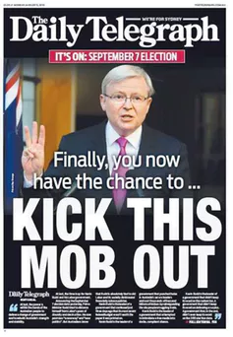

**Bibliography**

<https://newscorp.com/>

<http://theconversation.com/factcheck-does-murdoch-own-70-of-newspapers-in-australia-16812>

<https://en.wikipedia.org/wiki/Order_of_Australia>

<https://en.wikipedia.org/wiki/Rupert_Murdoch>

<https://en.wikipedia.org/wiki/News_Corp_Australia>

<https://en.wikipedia.org/wiki/List_of_assets_owned_by_News_Corp>

<https://en.wikipedia.org/wiki/News_Corp>

<https://en.wikipedia.org/wiki/News_Corporation>

<https://theconversation.com/murdoch-and-his-influence-on-australian-political-life-16752>

<http://insidethenation.com/2017/10/points-view-right-wing-versus-left-wing-rupert-murdoch-sky-limit/>